7.72: Following the hint, the force constant k is found from 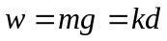, or 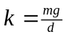. When the fish falls from rest, its gravitational potential energy decreases by mgy; this becomes the potential energy of the spring, which is 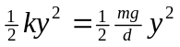. Equating these,
